Lesson 2.4 Internal and thermal energy

Recommended teaching time for this lesson: 1 x 60 minute period

• 30 minutes of explicit teaching

• 30 minutes of suggested classroom activities

• 30 minutes homework

Getting started

Learning intentions & success criteria

|  |  |
| --- | --- |
| I will: | I can: |
| understand the terms used to describe energy in a system. | * define:   + microscopic kinetic energy   + microscopic potential energy   + macroscopic kinetic energy   + macroscopic potential energy. * describe the types of microscopic potential energy. * state:   + the symbols used to represent system energy, macroscopic and microscopic kinetic and potential energy, chemical energy, nuclear energy and internal energy.   + the equations for calculating system energy, macroscopic and microscopic energy, and internal energy. * distinguish between:   + macroscopic and microscopic energy   + the changes to internal energy during heating and cooling. |
| understand the type of energy that transfers during heating. | * Describe:   + thermal energy   + the changes to internal energy during heating and cooling   + the changes to thermal energy during heating and cooling. * distinguish between:   + internal energy and thermal energy, |

Key ideas

* Microscopic (or internal) energy is the energy of particles at the atomic level, while macroscopic energy is the energy of the bulk.
* Thermal energy consists of microscopic kinetic energy and the microscopic potential energy stored within and between bonds.
* In thermal physics, microscopic energy, internal and thermal energy are the same.

Curriculum links

Science understanding

* Describe the kinetic particle model of matter.
* Describe the concepts of thermal energy, temperature, kinetic energy, heat and internal energy.

Advice for teaching this lesson

Things to know before you start teaching

When teaching this lesson, make sure your language is precise. You may want to consider how you will present this information visually because you will be referring to macroscopic and microscopic, along with kinetic and potential at both levels of scale. Ensuring students understand the connections between the terms will be critical for future explanations.

Common misconceptions

* Students often confuse thermal with internal energy at this point. This is because so far thermal energy is the only changing part of internal energy, and we are focusing on the ‘change in internal’. We will introduce work in Module 3, but ensuring students recognise the difference now will avoid needing to fix misunderstandings later, which could take more time.

Differentiation strategies

* STRIVE templates for ‘thermal energy’ and ‘internal energy’ are included, as well as a blank template for your future use. All students will benefit from them; however, they are created to assist students with language difficulties.
* Answers for prompt 5 for thermal energy are temperature and heat. For internal energy they are heat and potential energy.

Starter activity: What has more energy?

Approximate time: 5 minutes

**Activity placement:** Place directly above “What is microscopic energy?”

**Activity summary:** This is a simple comparative activity designed to start students thinking about commonsense assumptions that can lead to errors in physics.

Notes for the teacher

You could take a poll for each scenario by asking the whole class using simple call and response type answers or using larger movement around the room to have students indicate their answers.

Students will often try to avoid getting the question wrong by not providing any answer. Using physical movement can help you spot this, which provides for good opportunities to encourage students to embrace being wrong as a way to grow academically.

Instructions for students

For the following scenarios, what do you think has the most energy? Consider why, as you may be called on to provide your answer and reasoning.

* 1. a hot cup of tea (90°C) or an inflatable kiddie pool of warm water (30°C)
  2. a basketball on top of a 2-story building, or being passed by Michael Jordan
  3. 100 g of ice at 0°C or 100 g of water at 0°C

Helpful hints

* It’s okay to be ‘wrong’ here. Recognising our assumptions or misconceptions will let you learn more in the long run than being right all the time.

Answers

<Note to production: restart numbering below at ‘a.’>

* 1. A kiddie pool of warm water will have more energy. While the maximum temperature is less, there is more mass of water, so the total internal energy will be higher.
  2. The same basketball on top of a 2-story building (6 m) will have the equivalent kinetic energy of a ball being passed at about 9.3 ms−1 while about 1.5 m above the ground. Quick research suggests that the shooting speed of professional athletes is about 7.5 to 8.3ms−1.
  3. There is more internal energy inside 100 g of water than in 100 g of ice. While they are the same temperature, the bonds inside water have much more energy than the ice.

Classroom activity: Mind Mapping Concepts

Approximate time: 15 minutes

**Activity placement:** Place directly above “Check your learning 2.4”

**Activity summary:** This activity is designed to help students map out connections between concepts visually and introduce the idea of ‘mapping equations’ that will benefit them in their external exam preparation.

Notes for the teacher

Students can do this on their devices using any sort of blank canvassing tool. A simple paint program, Microsoft PowerPoint or any sort of mind map application/website is suitable.

You could have students do this by hand in class and then they can make a neat version digitally for homework. You would need to provide some A3 or butcher’s paper and some markers.

For more tactile students, you could encourage them to write out each term first, cut out the term and then move/assemble them on top of the paper.

This activity can easily take more than 15 minutes depending on how confident students are. If students seem hesitant or unable to start, begin by drawing the left side of the example answer on the board and asking them to complete the rest.

Instructions for students

Map out connections between concepts, with equations, as follows.

<Note to production: restart numbering below at ‘a.’>

* 1. Draw a mind map that connects the following terms: kinetic energy, potential energy, internal energy, thermal energy, macroscopic energy, microscopic energy, heat, system energy.
  2. Put equations along the lines between terms to demonstrate the relationships between the terms.

Helpful hints

* The section “How are all these terms connected?” can help guide you to get started.
* Practice reading the equations and try to represent these equations with words and lines between them.

Support activity

Map out connections between concepts, as follows.

<Note to production: restart numbering below at ‘a.’>

* 1. On a blank writing space – digital or physical – write the words “Macroscopic energy” and “Microscopic energy”.
  2. Draw a line connecting the two words, and then a line perpendicular from the middle point rising up. Write the term “System energy” at the top. Put the words ‘made of’ along the vertical line. An image of how this could look is attached.

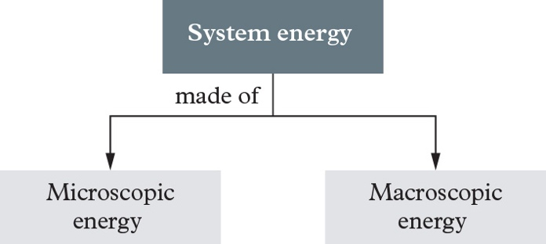

* 1. Continue with this pattern to add the following terms to the mind map: kinetic energy, potential energy, heat, internal energy, thermal energy. Some terms may appear more than once.

Challenge activity

Map out connections between concepts, with equations, as follows.

<Note to production: restart numbering below at ‘a.’>

* 1. Draw a Venn diagram of the following terms: kinetic energy, potential energy, internal energy, thermal energy, macroscopic energy, microscopic energy, heat, system energy. Your diagram will need more that the traditional two- or three-circle Venn diagrams you have seen in other subjects such as Maths.

Answers

a. and b. Student answers will vary. Here is a sample mind map showing the terms and equation connections.

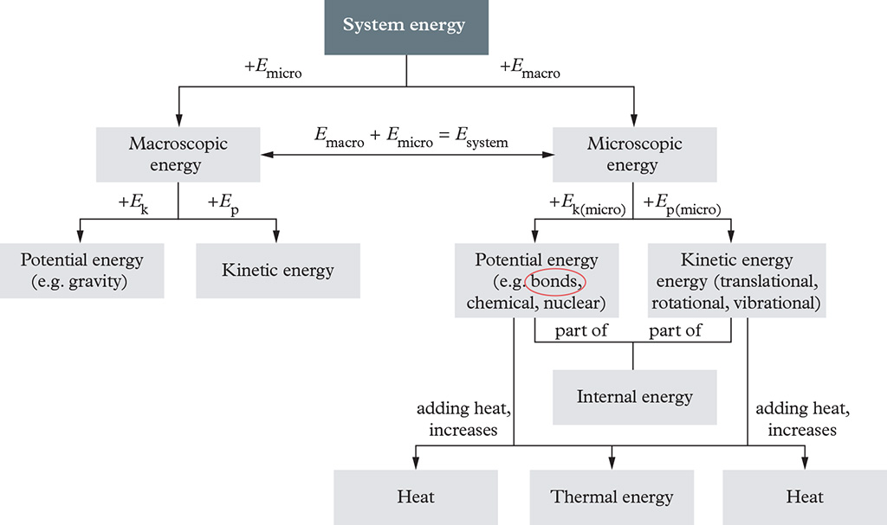

Support activity

a., b. and c. Student answers will vary. The following is a condensed form trying to minimise repeated terms.

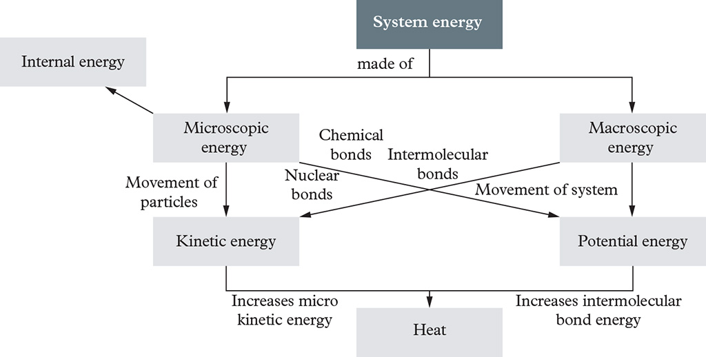

Challenge activity

<Note to production: restart numbering below at ‘a.’>

* 1. Student answers will vary. Here is a sample Venn diagram. Note that heat overlaps with thermal, but is also outside the system.

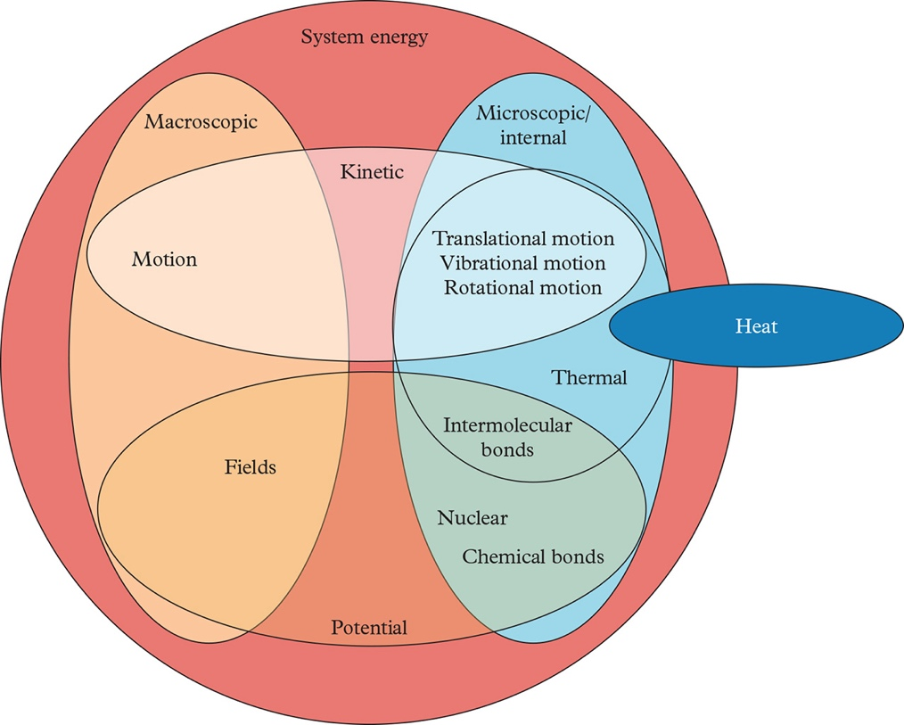

Classroom activity: Condensing notes – 10-5-2

Approximate time: 10 minutes

**Activity placement:** Place directly above “Check your learning 2.4”

**Activity summary:** This activity is to help students revise content into their own notes, and practice condensing into smaller forms. It also improves the complexity of writing by ensuring students are writing information-dense sentences.

Notes for the teacher

Often students put too much focus on perfect writing before they start writing. Keep an eye out for slow starters.

Instructions for students

Write a specific number of sentences about what you have learnt in this topic, reducing the number of sentences as instructed. Ensure you use all vocabulary words from the success criteria. Alternatively, you can find them as the bolded words in the text for this module.

<Note to production: restart numbering below at ‘a.’>

* 1. Write 10 sentences about what you have learnt in this topic.
  2. Rewrite your 10 sentences into 5 sentences.
  3. Rewrite your 5 sentences into 2 sentences.

Helpful hints

* As you try to increase the density and brevity of your writing, look for connections between ideas and similarities. For example, there are both macroscopic and microscopic forms of kinetic and potential energy.

Answers

Student answers will vary. An example is provided below. Notice that the depth will reduce, and brevity will increase; however, the last version can be excellent for creating condensed study notes, while the second can help with word count in IA2/3.

<Note to production: restart numbering below at ‘a.’>

* 1. Ten sentences: There are many forms of energy when talking about matter. Energy can come in macroscopic and microscopic forms. Macroscopic energy is the energy of the whole object, and we can see it daily. For example, macroscopic kinetic energy is when I throw a ball at a friend, while macroscopic potential energy is found when objects are placed up high or near magnets. Microscopic energies generally can’t be seen when looking at an object. The microscopic kinetic energy is held in the movement of the particles such as vibration or rotation, while microscopic potential energy is in the bonds between particles, between atoms in molecules and within the atom itself. The thermal energy of an object is the energy that comes from the temperature. Increasing the temperature will increase the internal energy of the object and manifest as more movement and energy stored in the bonds between particles. Heat is energy moving in or out of the system, and either increasing or decreasing both the thermal and internal energy. When the thermal energy changes, so too does the movement of the particles and bonds.
  2. Five sentences: Energy in a system can be macroscopic or microscopic, and these both have kinetic and potential energies. The kinetic energy of a system involves movement; at the macroscopic scale this is the whole object moving, but at the microscopic scale it is the movement of the particles which reflects how much thermal energy a system has. The potential energy of the system involves stored energy such as in the gravity field (macroscopic) or within the bonds – intermolecular, chemical and nuclear – within the system (microscopic). If thermal energy is given to the system, the internal energy increases which changes the microscopic kinetic energy, as well as the intermolecular bonds of the system. This addition of energy to the system is called heat.
  3. Two sentences: Macroscopic energies – kinetic and potential – relate to the whole system such as its movement or location. Microscopic or internal energies – kinetic and potential – relate to the properties of the individual atoms such as the movement of its particles, and the intermolecular bonds between them, and can be changed by the addition of thermal energy in the form of heat.